PIZZA SALES REPORT

**SQL Quarries**

1. **KPI’s: -**
2. **Total Revenue:**

Select SUM(total_price) AS Total_Revenue From Pizza_sales

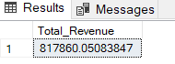

1. **Average Order Value**

Select SUM(total_price) / COUNT(Distinct order_id) AS Avg_order_Value From Pizza_sales

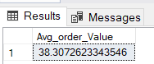

1. **Total Pizzas Sold**

Select SUM(quantity) As Total_Pizza_Sold From Pizza_sales

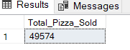

1. **Total Orders**

Select COUNT(Distinct Order_id) As Total_orders From Pizza_sales

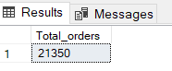

1. **Average Pizzas Per Order**

Select CAST(CAST(SUM(quantity) As DECIMAL(10,2)) /

CAST(COUNT(Distinct order_id) AS Decimal(10,2)) AS Decimal(10,2)) As Avg_pizza_per_order

From Pizza_sales

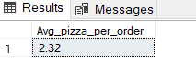

1. **Daily Trend for The Total Order: -**

Select DATENAME(DW, order_date) AS order_day,

COUNT(Distinct order_id) As Total_orders

From Pizza_sales

Group By DATENAME(DW, order_date)

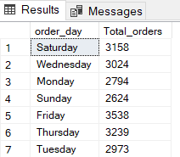

1. **Monthly Tend For Order:-**

Select DATENAME(Month, order_date) AS Month_Name,

COUNT(Distinct order_id) AS Total_Order

From Pizza_sales

Group By DATENAME(Month, order_date)

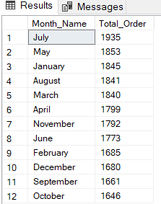Order By Total_Order DESC

1. **% Of Sales By Pizza Category: -**

Select pizza_category, SUM(total_price) As Total_Sales, SUM(total_price) * 100 /

(Select SUM(total_price) from Pizza_sales Where MONTH(order_date) = 1)AS Total_Percent_Sales

From Pizza_sales

Where MONTH(order_date) = 1

Group By pizza_category

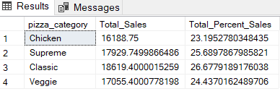

1. **% Of Sales By Pizza Size: -**

Select pizza_size,CAST(SUM(total_price) As decimal(10,2)) As Total_Sales, CAST(SUM(total_price) * 100 /

(Select SUM(total_price) from Pizza_sales Where DATEPART(Quarter, order_date) = 1) AS decimal(10,2))

AS Total_Percent_Sales

From Pizza_sales

Where DATEPART(Quarter, order_date) = 1

Group By pizza_size

Order By Total_Percent_Sales DESC

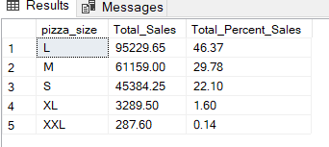

1. **Top 5 Pizza Sales By Revenue: -**

Select Top 5 pizza_name, SUM(total_price) AS Total_Revenue from pizza_sales

Group By pizza_name

Order By Total_Revenue DESC

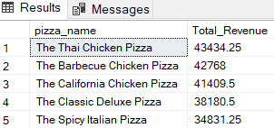

1. **Bottom 5 Pizza By Revenue: -**

Select Top 5 pizza_name, SUM(total_price) AS Total_Revenue from pizza_sales

Group By pizza_name

Order By Total_Revenue

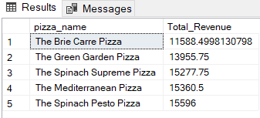

1. **Top 5 Pizza By Quantity: -**

Select Top 5 pizza_name, SUM(quantity) AS Total_quantity from pizza_sales

Group By pizza_name

Order By Total_quantity DESC

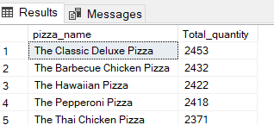

1. **Bottom 5 Pizza By Quantity: -**

SELECT TOP 5 pizza_name, SUM(quantity) AS Total_Pizza_Sold

FROM pizza_sales

GROUP BY pizza_name

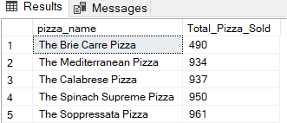ORDER BY Total_Pizza_Sold ASC

1. **Top 5 Pizza By Total Order: -**

Select Top 5 pizza_name, COUNT(Distinct order_id) As Total_order From pizza_sales

Group By pizza_name

Order by Total_order DESC

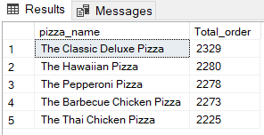

1. **Button 5 Pizza By Total Order: -**

Select Top 5 pizza_name, COUNT(Distinct order_id) As Total_order From pizza_sales

Group By pizza_name

Order by Total_order

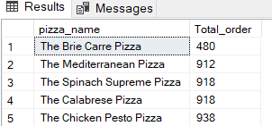

**NOTE**

If you want to apply the pizza_category or pizza_size filters to the above queries you can use WHERE clause. Follow some of below examples

SELECT Top 5 pizza_name, COUNT(DISTINCT order_id) AS Total_Orders

FROM pizza_sales

WHERE pizza_category = 'Classic'

GROUP BY pizza_name

ORDER BY Total_Orders ASC